New Imaging Spectrometric Method for Rotary Object
CHUN Yu ¹, DONG Xiao-xue²
- Department of Electronic Engineering, School of Information Science
and Technology, Beijing Institute of Technology, Beijing 100081,
China; 2. School of Mechatronic Engineering, Beijing
Institute of Technology, Beijing 100081,China)

Abstract: A new technique for imaging spectrometer for rotary object based on computed-tomography is proposed. A discrete model of this imaging spectrometric system is established, which is accordant to actual measurements and convenient for computation. In computer simulations with this method, projections of the object are detected by CCD while the object is rotating, and the original spectral images are numerically reconstructed from them by using the algorithm of computed-tomography. Simulation results indicate that the principle of the method is correct and it performs well for both broadband and narrow-band spectral objects.

Key words: aerodynamic characteristics; stealth characteristics; numerical calculation; polarization
CLC number: TP374.2 Document code: A Article ID:

Introduction
**************************************************************************************************************************************************************

1 ******************

1.1 *****************

1.1.1 *****************

2 ******************

3 ******************
***********************************************************************************************************************************************************************************************************************************************************************************************************************************************************************************************************
$ρ\frac{D\tilde{ν}}{Dt}=G_{ν}+\frac{1}{σ_{\tilde{ν}}}\left\{\frac{∂}{∂x_{j}}\left[\left(μ+ρ\tilde{ν}\right)\frac{∂\tilde{ν}}{∂x_{j}}\right]+C_{b2}ρ{\left(\frac{∂\tilde{ν}}{∂x_{j}}\right)}^{2}\right\}−Y_{ν}$ (1)
Sponsored by the National Natural Science Foundation（60217289）
Biography CHUN Yu（1963—），professor，Ph.D.， abcd@sina.com.
*********************************************************************************************************************************************************************************************************************************************

Fig. 1 The dual meander line monopole antenna
b
b
β
h₁
h₂
α
w
d

Fig.2 Flow chart of simulation for standing start acceleration process
end
establishing model
check
data correct
adjusting
importing data
calculating
adjusting
data being correct
adding the trunk
calculating results
Y
Y
N
Y
N
N

******************************************************************************
******************************************************************************
******************************************************************************

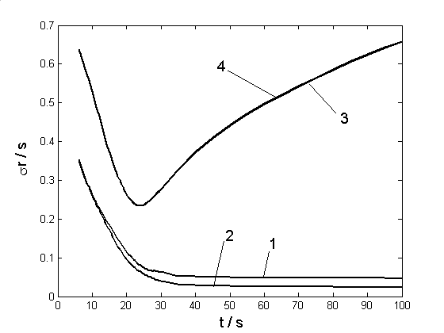
Fig.3 Regression residual error vs. time

******************************************************************************
******************************************************************************
******************************************************************************

Tab.1 Resonant parameters for different n

n | f₀/MHz | R/Ω | V_{SWR} | B_{W}/% | L/cm
line | 955 | 36.4 | 1.36 | 15.4 | 7.0
0 | 804 | 30.7 | 1.56 | 22.0 | 7.0
1 | 750 | 27.8 | 1.73 | 17.3 | 8.6
2 | 706 | 23.6 | 2.0 | 12.7 | 10.2
3 | 670 | 21.6 | 2.17 | 9.4 | 11.8
4 | 642 | 20.1 | 2.37 | 6.38 | 13.4

References:
- SCHÖLKOPF B, BURGES C J C, Smola A J. Advances in kernel methods – support vector learning [M]. Cambridge,MA: MIT Press, 1999.
- HEARST M A, SCHÖLKOPF B, DUMAIS S, et al. Trends and controversies – support vector machines [J]. IEEE Intelligent Systems, 1998,13(4):18-28.
- ERIC C. Hacker’s attack analyze and defense[M]. SU Lei, transl. Beijing: Publishing House of Electronics Industry,2002.
- Burges C J C. Geometry and invariance in kernel based methods[C]//BURGES C, SMOLA A. Advance in Kernel Methods—Support Vector Learning. Cambridge, MA: MIT Press,1999.
- JIA Yubin. A study on micro quartz angular rate sensor[D]. Beijing: Department of Optical Engineering, Beijing Institute of Technology,1999.
- CHANG C C, LIN C J. LIBSVM: A library for support vector machines [EB/OL]. (2001-06-19)/[2002-03-10]. http://www.csie.ntu.edu.tw/cjlin/libsvml.
- SWANSON R S, MUSA S. The estimation of obstacle and terrain clobber probabilities, AIAA 75-1118[R]. Cambridge: University of Cambridge Press, 1975.
- White S A. Tracking filter and quadrature-phase reference generator:US[P].1996-01-13.
- GJB 736.8-90, Method of initiating explosive device test, accelerated life test, method of the test at 71℃[S].

